Database-attach full upgrade to Project Server 2010
When you upgrade from Microsoft Office Project Server 2007 to Microsoft Project Server 2010 by using the database attach upgrade process, you upgrade only the content for your environment, and not the configuration settings. Using a database attach upgrade process is useful when you are changing hardware or want to reconfigure your server farm topology as part of the upgrade process. It is also required if you are upgrading from Office Project Server 2007 deployed on a hardware that only supports a 32-bit server operating system.
Before you begin the database attach full upgrade to Office Project Server 2007, review the following information about permissions, hardware requirements, and software requirements. Follow the specified steps to install or configure prerequisite software or to modify settings.

Review required permissions
You must have at least the following permissions to complete the procedures in this article:
- On the database server from which the databases are being detached you must be a member of the following roles:
  - The db_owner fixed database role.
  - The db_backupoperator fixed database role.
- On the server farm to which the databases are being attached, you must be a member of the local Administrators group, and you must be a member of the following roles on the database server:
  - The dbcreator fixed server role.
  - The db_owner fixed database role.
- In some environments, you must coordinate the move procedures with the database administrator. Be sure to follow any applicable policies and guidelines for handling databases.

Review required hardware and software
You must be running one of the following products on the database servers to perform these procedures:
- On your Office Project Server 2007 environment: the Microsoft SQL Server Client tools for SQL Server 2000, SQL Server 2005, or SQL Server 2008. These are required to back up your required databases.
- On your project server 2007, you need to install project server service pack 1, 2 and cumulative update for project server (oct 2009) and Windows SharePoint Services 3.0 with SP2
- On your Project Server 2010 environment: a 64-bit version of one of the following products:
  - SQL Server 2008 Service Pack 1 with Cumulative Update 2
  - SQL Server 2005 Service Pack 3 with Cumulative Update 3

Database attach full upgrade overview
A database attach full upgrade will upgrade your Office Project Server 2007 databases and will also restore and the Project Web Access site's content database to your Project Server 2010 farm. The following databases are upgraded in a database attach full upgrade:
- Draft
- Archive
- Publish
- Reporting
- SharePoint content database (containing your Project Web Access site data)
A database attach full upgrade differs from a database attach core upgrade in the fact that the core upgrade will only upgrade your Office Project Server 2007 databases, migrating only your Office Project Server 2007 project data.
To perform a database attach full upgrade, you must follow these general steps:

Verify your Project Server 2007 data
You must verify that your Office Project Server 2007 data is in a valid state to help ensure that your upgrade will be successful. You must verify the following:
- All projects should be checked-in.
- The Project Web App site name of "ProjectBICenter" is reserved in Project Server 2010. Verify that Office Project Server 2007 does not use this as a Project Web App site name.
- The list name of "Project Detail Page" is reserved in Project Server 2010. Verify that Office Project Server 2007 Project Web Access does not contain a list with this same name.
- Resolve all custom field and lookup table name conflicts with names that are reserved in Project Server 2010..

Custom field and lookup table name conflicts
There are certain custom fields and lookup tables name that are reserved in both Office Project Server 2007 and Project Server 2010. If you are upgrading from Office Project Server 2007, verify that you do not have custom field names that are in conflict with the names reserved for Project Server 2010. If any of these names are used in the current Office Project Server 2007 database, the custom fields and outline codes must be changed in Office Project Server 2007 before proceeding further with the migration. Use Microsoft Office Project Professional 2007 connected to a Office Project Server 2007 instance to validate and take corrective action.

Reserved outline code names
Outline code name | Type | Office Project Server 2007 | Project Server 2010
Cost Type | Resource | X | X
Health | Task | X | X
State | Project | X | X
Team Name | Resource | X | X
Department |  |  | X
Flag Status |  |  | X

Reserved custom field names
Custom field name | Type | Office Project Server 2007 | Project Server 2010
Cost Type | Resource | X | X
Health | Task | X | X
State | Project | X | X
Team Name | Resource | X | X
Sample Approved Finish Date | Project |  | X
Sample Approved Start Data | Project |  | X
Sample Areas Impacted | Project |  | X
Sample Assumptions | Project |  | X
Sample Business Need | Project |  | X
Sample Compliance Proposal | Project |  | X
Flag Status | Task |  | X
Sample Goals | Project |  | X
Sample Post-Implementation Review Date | Project |  | X
Sample Post-Implementation Review Notes | Project |  | X
Sample Primary Objectives | Project |  | X
Project Departments | Project |  | X
Project Impact | Project |  | X
Sample Proposal Cost | Project |  | X
Sample Proposed Finish Date | Project |  | X
Sample Proposed Start Date | Project |  | X
Relative Importance | Project |  | X
Resource Departments | Resource |  | X

Extract your Project Web Access site from a content database to a new content database (Optional)
If you do not have a separate content database for your Project Web Access site, your Project Web App site data may share its content database with data from other sites. In this situation, we recommend that you extract the Windows SharePoint Services site collection for PWA into a new content database.
Using this procedure has the following requirements.
- You must have a fully functional Office Project Server 2007 farm.
- You must have administrative access to the computer in which the farm is running.
- In your Office Project Server 2007 farm, you must have at least one Web application (other than the Web application where your Project Web App site exists). A new Web application on http://server:82 is an example of such an application.
- You know where your Stsadm command-line tool exists. The default location is: %PROGRAMFILES%\Common Files\Microsoft Shared\Web Server Extensions\12\BIN.

To extract Project Web Access site content from a content database to a new content database:
- Identify the URL of the site collection you want to back up (for example, http://server/PWA).
- Use the following stsadm command to back up the site collection:
Stsadm –o backup –url <SiteURL> -filename <FullPathToBackupFile>
For example: Stsadm –o backup –url http://server/pwa -filename c:\temp\backup.bak
- Use the following Stsadm command to create a new content database in your second Web application.
Stsadm.exe –o addcontentDB –url <NewWebAppURL> -ds <SQLServerName> -dn <NewContentDBName>
For example: Stsadm.exe –o addcontentDB –url http://server:82 -ds CorpSQL1 -dn PWAContentDB
- Use the following Stsadm command to restore the site collection to the second Web application.
Stsadm –o restore –url <SiteURL> -filename <FullPathToBackupFile>
For example: Stsadm –o restore –url http://server:82/NewPWA -filename c:\temp\backup.bak
Make sure the site URL that you intend to use while restoring does not already exist in the new Web application (or else this procedure will fail). You are not required to use the same name you used during backup.
The name you use to restore should be the name you intend to use when you upgrade the data to Project Server 2010.

Back up the databases in SQL Server

To back up a database in SQL Server
- On the database server, click Start, point to All Programs, point to Microsoft SQL Server 2005, and then click SQL Server Management Studio.
- In the Connect to Server box, fill in the connection information, and then click Connect.
- After you connect to the appropriate instance of the SQL Server 2005 Database Engine, in Object Explorer, expand the server tree by expanding the server name.
- Expand Databases, right-click the database that you want to back up, point to Tasks, and then click Back Up. The Back Up Database dialog box appears.
- In the Source area, in the Database box, verify the database name.
- In the Backup type box, select Full.
- Under Backup component, select Database.
- In the Backup set area, in the Name text box, either accept the default backup set name that is suggested or type a different name for the backup set.
- In the Destination area, specify the type of backup destination by selecting Disk or Tape, and then specify a destination. To create a different destination, click Add.
- Click OK to start the backup process.

Restore the backup copies to the new farm
After you have configured the new Project Server 2010 server farm, you can restore the backup copies of the databases on the SQL Server instance that you are using to host your Project Server 2010 databases. Note that you must restore to a 64-bit version of SQL Server 2008 SP1 with CU2, or 64-bit SQL Server 2005 SP3 with CU3. Start with one database, and then verify that the recovery has worked before you restore the other databases
- After you connect to the appropriate instance of the SQL Server 2008 Database Engine, in Object Explorer, expand the server name.
- Right-click Databases, and then click Restore Database. The Restore Database dialog box appears.
- In the Restore Database dialog box, on the General page, type the name of the database to be restored in the To database list.
- In the To a point in time box, retain the default (Most recent possible).
- To specify the source and location of the backup sets to restore, click From device, and then click Browse to select the backup file.
- In the Specify Backup dialog box, in the Backup media box, be sure that File is selected.
- In the Backup location area, click Add.
- In the Locate Backup File dialog box, select the file that you want to restore, click OK, and then, in the Specify Backup dialog box, click OK.
- In the Restore Database dialog box, under Select the backup sets to restore grid, select the Restore check box next to the most recent full backup.
- In the Restore Database dialog box, on the Options page, under Restore options, select the Overwrite the existing database check box.
- Click OK to start the recovery process.
Repeat the previous procedure to restore the remaining required databases.
After restoring the 5 databases in your project server environment you need to attach the wss_content database, before attaching run the psconfig command to upgrade.

To run psconfig
- Open a Command Prompt window as an Administrator.
- Navigate to \program files\common files\Microsoft shared\Web server extensions\14\bin.
- Run the following command:
psconfig -cmd upgrade -inplace b2b

Add the restored content database to the Project Server 2010 farm
- Open a Command Prompt window as Administrator, and navigate to:
%PROGRAMFILES%\Common Files\Microsoft Shared\Web Server Extensions\14\BIN
- Run the following:
STSADM.EXE –o addcontentDB –url <WebAppURL> -databaseserver <SQLServerName> -databasename <WSSContentDBName>
For example : stsadm.exe –o addcontentdb –url http://astroepm:17317/astrowix -ds astroepm -dn wss_content_restore
The database name should be the exact name of the content database you restored to SQL Server in the previous procedure. When the command prompt returns, the step has been completed.
- Monitor the upgrade logs for failure. The Upgrade logs are located at: %PROGRAMFILES%\Common Files\Microsoft Shared\Web Server Extensions\14\Logs

Provision a new Project Server 2010 PWA instance using the restored databases
In Project Server 2010, you can now create a Project Web App instance using the Office Project Server 2007 databases you restored to SQL Server in the previous step. When the instance is created, the restored databases will be upgraded to Project Server 2010.

Create a Project Server 2010 Project Web Access instance using the restored Project Server 2007 databases
- On SharePoint Central Administration Web site, in the Application Management section, click Manage service applications.
- On the Manage Service Applications page, click Project Server Service Application.
- On the toolbar, click Manage.
- On the Manage Project Web Access Sites page, click Create Project Web Access Site.
- On the Create Project Web Access Site page:
  - In the Project Web Access Site Location and Administrator Account fields, keep the default values.
  - In the Primary Database field, type the name of the database server where your restored Office Project Server 2007 databases are located.
  - Verify that the names of the Project Server databases match the names of the restored Office Project Server 2007 databases that you will use. If they do not, change them so that they match.
- Click OK.
Note: The databases names must be exact matches with the restored Office Project Server 2007 database names in SQL Server. If the names do not match, a new Project Server 2010 database will be created and the restored Office Project Server 2007 database will not be upgraded.
Project Server will start the PWA site creation process. Click Refresh occasionally to view the status of the instance provisioning. Be patient as this occurs, as it may take a while to finish. When the site creation process has finished, the status shown on the PWA site list is Provisioned.
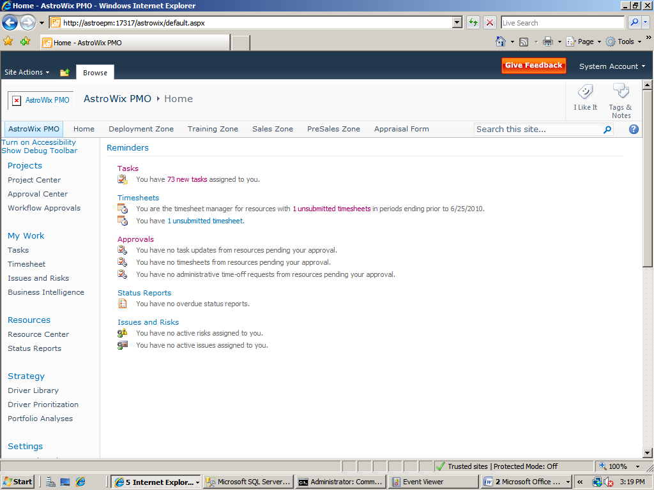
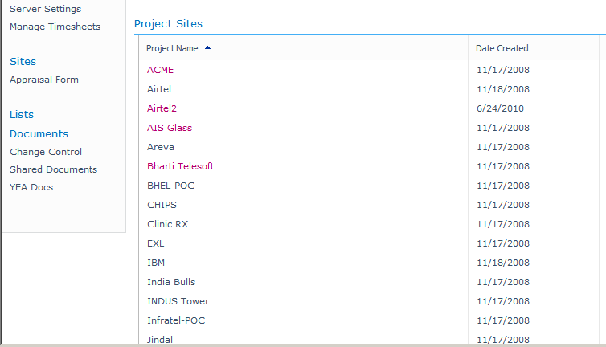
Project Center View
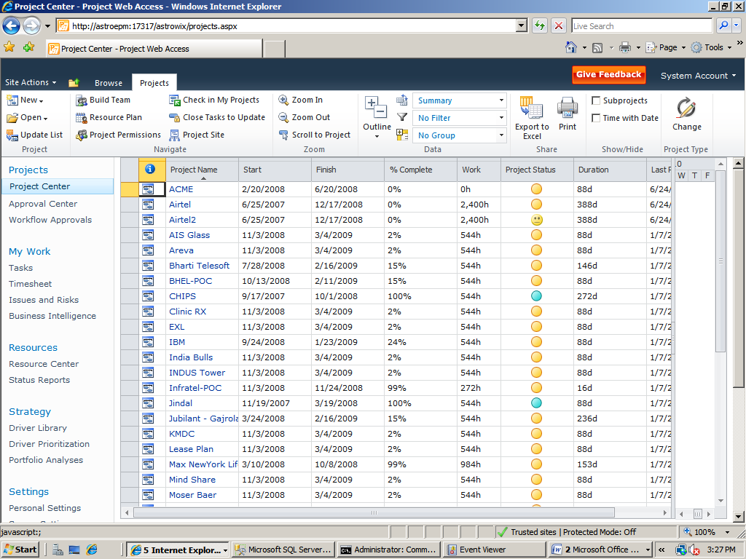

Project Site
